Lasupe Xiong
CS 330
Instructor Scott Gray
01/18/26
2-3 Milestone
For my final project, I chose a photograph of a laptop workplace scenario as the 2D image to 3D model. The image depicts a laptop on a desk, surrounded by many things. This scene depicts a clear and realistic landscape that is easily recreated with OpenGL and simple 3D shapes.
The image features a variety of unique objects that can be classified into primitive shapes such as boxes, planes, cylinders, and toruses. Because the objects are largely geometric and man-made, they are ideal for recreating with the basic shapes needed for this course.
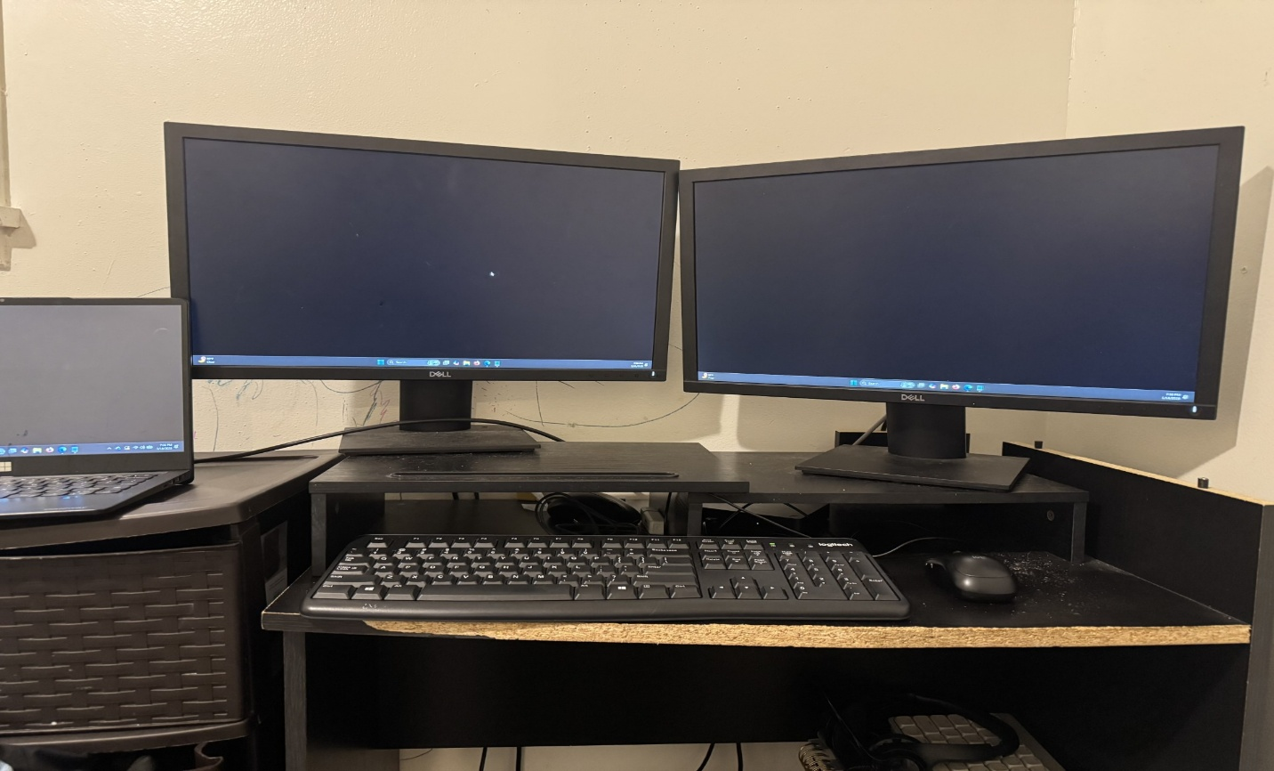
Objects to Be Replicated in 3D
From this image, I plan to replicate the following objects:
- Laptop (complex object)
- Computer mouse
- Coffee mug (additional object for scene completeness)
- Desk surface (ground plane)
- Notebook or smartphone (additional object for scene completeness)
These objects were chosen because they are plainly visible, easy to distinguish, and adequate in complexity for a course assignment. Because of its several diverse components and shapes, the laptop will function as the requisite complicated item. The remaining things are basic enough to model while leaving room for creativity and intricacy.
Together, these objects form a realistic and structured workstation scenario that will be fun to design and render in OpenGL.
Breakdown of Basic 3D Shapes
To recreate the selected objects, I will use the following primitive shapes:
1. Laptop – Complex Object
The laptop will be the most intricate object in the picture, consisting of several shapes:
- Box: Main base of the laptop
- Box: Laptop screen
- Plane: Keyboard surface
- Small boxes: Individual keyboard keys
- Cylinders: Hinges connecting the screen and base
This object meets the project criteria for creating at least one complicated object from two or more diverse 3D shapes.
2. Computer Mouse
The mouse can be recreated using:
- Tapered cylinder or stretched sphere: Main body of the mouse
- Plane: Mouse pad
This object provides more shape, variety and authenticity to the scene.
3. Coffee Mug
The mug is another object that can be broken into multiple primitives:
- Cylinder: Main body of the mug
- Torus: Handle
- Plane: Bottom surface
Including the mug allows the scenario to employ the torus shape, which contributes to meeting the criteria of using at least four different primitive shapes.
4. Desk Surface
- Plane: The desk will serve as the ground plane for the scene
This is essential for the project to provide a surface on which all other items can rest.
5. Notebook or Smartphone
As an additional simple object:
- Box: Main body
- Plane: Screen or cover surface
This object fills empty space in the scene and improves the overall visual balance.
Justification and Feasibility
The chosen scene is both interesting and feasible given the constraints of this course. All items can be properly reduced to primitive shapes while remaining recognizable. This scene includes:
- At least four different objects
- At least one complex object (the laptop)
- Use of more than four different 3D shapes (box, plane, cylinder, torus, sphere/tapered cylinder)
- A required plane as the base
This guarantees that all project needs are met while also providing opportunities to experiment with textures, lighting, and transformations.
By selecting a familiar everyday workstation setting, I will be able to concentrate on learning how to build and manage 3D objects in OpenGL without being overwhelmed by needless complexity.
This laptop desk setting serves as a wonderful base for my final project. It has enough items and variety to satisfy all technical requirements while being manageable for development. I am convinced that this scenario will allow me to exhibit my knowledge of 3D modeling, transformations, and rendering with OpenGL.

